Mihanwebhost.com-AminShafaati
- 'The religious and moral authorities… attempt to instill nonviolence… through the application of violence… Violence and the sacred are inseparable' (René Girard). 'Gewaltverbrechen des Staates unter dem Vorwand der Bekämpfung von Gewaltverbrechen des Volkes' (Ernest Borneman).
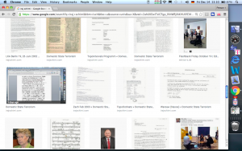
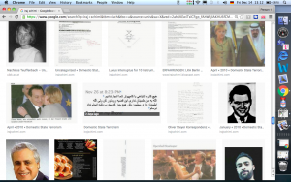
Toward the end of Nov. the architect Amin Shafaati (a staunch defender of the Current), from Lahijan brought two men to my place.
I am now under severe stress and time pressure, Dec 1 2018. See the censored files: 'Austrian-Iranian Citizen' and 'MV-Sarafi-Shiraz': 'Don't miss the honor of giving me a coup de grâce!'. Well, I have done nothing unlawful!. I expect that soon the whole webpage gets censored too.
One of the men inserted a USB disk into my laptop… Countless problems after that… Shafaati had been very helpful to me since 6 months here. I was very happy to have him, paid him 1.2 million Tomans (3×300,000, 1×200,000, 1×100,000). He refused to give the names of those men long time.
- Seit über 40 Jahren lebe ich mit mehr oder weniger Intensität in der Hölle. Nur der Hass auf das Bestehende und die Möglichkeit ihn zum Ausdruck zu bringen, hält mich am leben.
I wrote to Shafaati (Nov 25 2018):
The Sweet Taste of Betrayal
- What you did to me belongs to the most dirtiest, criminal-destructive aspects of human being instigated by the ruling power.
"Only through participation in the ritual destruction of the Other, only through committing existential cannibalism, is man admitted to membership in the modern State" (Szasz). C.f. the Christian counterpart, file 'Nikos Grivas'.
"Der Staat rechtfertigt das Gewissen, gewissenlos zu sein" (Glaser).
Wrote him; You (backstabber, traitor)…
One of the strange phenomena after USB disk:
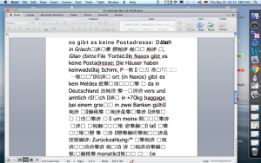
Other examples.
Clicking on the webpage to open, came this:
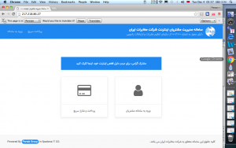
, or this:
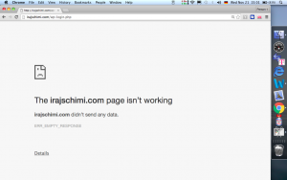
, or this:
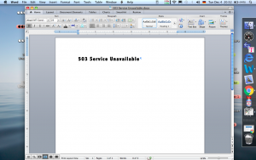
, after long waiting!
[['Iranian hackers working to penetrate systems, businesses and governments around the world have caused hundreds of millions of dollars in damages… Microsoft traced the attacks to Holmium, a group linked to Iran, and that some of the hacking was done for Holmium by another Iranian group known as APT33… In 2017, the security firm FireEye blamed APT33 for destructive malware that targeted organizations in the Middle East and elsewhere' (Yahoo March 8 2019). We add to 'Holmium' and 'APT33', also 'mihanwebhost.com' for home use. You 'Verbrecher, Einbrecher, Paranoiker [Folterer von Nasrin Sotudeh (Akhoondestan against Prostitution) und zahlreich anderen anständigen Menschen, Jouurnalisten…]. Du zitterst vor Angst, fühlst dich bedroht, da ich noch atme. Du, göttlich-krimineller Geist und höchst stupid!_, wahnsinniger Verbrecher ('Wahn und Verbrechen, Jonoon va Jenayat, sacred and violence').

Ein 'Menschsein…, das sich nur durch Tod und Zerstörung lebendig fühlt' (Arno Gruen). Gott als 'Gegensein'_ 'Todestrieb': rein!'.

Drei Dreck-'Martike' (Farsi), Shafaati, Akbari, Ramezani, als Repräsentanten von 'Islamic republic's clerical establishment' (President Rouhani, Yahoo March 6 2019). This 'clerical establishment'_ shored up by 'a human rights professor' ('I am a human rights professor,' Iranian FM Zarif responds to question on rights abuses (Yahoo Feb 19 2019)_ has been hostile to me right from its onset (inter alia: 'MV-Sarafi-Shiraz', 'Austrian-Iranian Citizen', 'Forbidden', 'Strong Republic')]]
The above examples I had never before, and laptop had become extremely slow. The man copied as much as possible files from the computer and put into it '503 Service Unavailable', under the pretence of how to do the renewal of the webpage and VirusBarrier from Iran.
In the kitchen I gave Shafaati a piece of bread I had baked. He gave then, in front of me, a piece of that to the man working on my laptop.
- C.f. file: 'Forbidden' and 'Strong Republic'.

- After editing the webpage I want to stop working on it and log out. It says: log in. Log out not possible.

- I copied 503 Service Unavailable, left it on the screen. When I double click on its icon my webpage appears. When I go there to Meta Site Admin it says Log out_ meaning that it is open, already logged in.

- 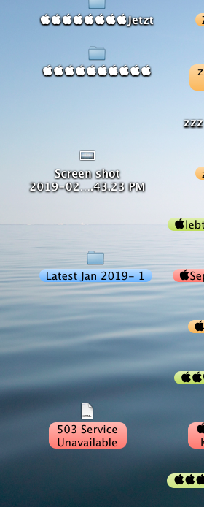

- I had added a new file: 'Ö Zusatz 2 New'. When I click on 'Edit', it comes a blank page.
*
Maybe one day after USB-Attack.
Iraj Schimi
Nov 22 2018
To Amin
Aminjan,
inter alia this happened yesterday:
Ghorbanat!
Iraj
(jan = life. My …jan: 'dearest'! Ghorbanat: an intimate word for goodbye). Holocaust-Überlebender Friedländer: 'Für die meisten Juden war das, was ihnen bevorstand, unvorstellbar, selbst angesichts untrüglicher Vorzeichen'.
*
Amin Shafaati <XXXXXXXXXXXX>
To
Iraj Schimi
Nov 22 at 5:20 PM
Hi
Daryaft shod email shoma
Translation: 'Your email received'. [Nothing before and after that. 'Emaiie to' is intimate form in Farsi. 'Emaile shoma' is polite form]
*
Iraj Schimi (XXXXXXXXXXXX)
To
Amin Shafaati
Nov 25 at 11:04 AM
The Sweet Taste of Betrayal
What you did to me belongs to the most dirtiest, criminal-destructive aspects of human being instigated by the ruling power.
"Only through participation in the ritual destruction of the Other, only through committing existential cannibalism, is man admitted to membership in the modern State" (Szasz).
"Der Staat rechtfertigt das Gewissen, gewissenlos zu sein" (Glaser).
Reply Reply to All Forward More
*
Amin Shafaati <XXXXXXXXXXXXX >
To
Iraj Schimi
Nov 26 at 8:19 PM
Hi
Man motevajeh nemisham english ke migii
Moshkeli pish oomade??
Sent from my iPhone
Translation: I don't understand when you speak English. Any troublesome occurrence?
*
Amin Shafaati <XXXXXXXXXXXXX>
To
Iraj Schimi
Nov 26 at 8:23 PM
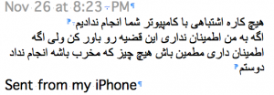
Translation: 'We did nothing wrong to your computer'.
Inserting a USB disk into your laptop, while you were with me in the kitchen, and copying files is not something wrong for your computer.
'If you don't trust me believe this. But if you trust me, be sure, nothing was done by my friend that could be destructive'.
*
Amin Shafaati <XXXXXXXXXXXXXXXX>
To
Iraj Schimi
Nov 26 at 8:23 PM
?? ?? ????? ??? ?????? ???? ???? ???? ??? ???? ? ???? ????
Sent from my iPhone
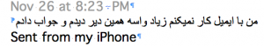
Translation: I don't work much with email that's why I saw it late and answered.
*
Iraj Schimi <XXXXXXXXXXXXX>
To
Amin Shafaati
Nov 27 at 6:21 PM
I am asking you the names and emails of those two men you brought to my pace.
*
Amin Shafaati <XXXXXXXXXXXXXX>
To
Iraj Schimi
Nov 27 at 11:47 PM
Ok
Asking them and answer you
Sent from my iPhone
*
Iraj Schimi <XXXXXXXXXXXXX>
To
Amin Shafaati
Dec 1 at 4:52 PM
You wrote (Nov 27):
'Asking them and answer you'.
You (backstabber, traitor) mean you will ask them and you will answer me? No answer I have received yet!
[He wants to ask them whether they allow to give me their names!]
*
Amin Shafaati <XXXXXXXXXXXXXX>
To
Iraj Schimi
Dec 1 at 8:15 PM
Rakbari.wm…
Sent from my iPhone
[Nothing before and after that].
*
Iraj Schimi <XXXXXXXXXXXXX>
To
Amin Shafaati
Dec 2 at 12:02 AM
Rakbari.wm…
Which guy is he? with or without beard?
Write me in Farsi (you sculpture of dirt, criminal, in Farsi: MUZI ['underhand, shifty'].
*
Iraj Schimi <XXXXXXXXXXX>
To
Amin Shafaati
Dec 2 at 11:13 AM
Your email, Dec 1:
Rakbari.wm…
Again: I asked you what are the names (it means first and last names) and emails of those two men you brought to my place…
*
Iraj Schimi <XXXXXXXXXXX>
To
Amin Shafaati
Dec 2 at 11:20 AM
Your email, Dec 1:
Rakbari.wm…
Again: I asked you what are the names (it means first and last names) and emails of those two men you brought to my place…
: First and last name of the one with beard:…
: First and last name of the one without beard:…
*
Amin Shafaati <XXXXXXXXXXXXXXX>
To
Iraj Schimi
Dec 3 at 10:12 AM
???? ?? ?? ?? ??? ??? ??? ?????
Sent from my iPhone
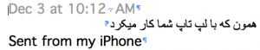
Translation: The one who was working on your laptop. [Not correct. As it reveals below, the other man with beard was working on my laptop]
*
Iraj Schimi <XXXXXXXXXXXXX>
To
Amin Shafaati
Dec 3 at 2:38 PM
Again: I asked you what are the names (it means first and last names) and emails of those two men you brought to my place…
: First and last name of the one with beard:…
: First and last name of the one without beard:…
*
Amin Shafaati <XXXXXXXXXXXXX >
To
Iraj Schimi
Dec 3 at 4:24 PM
Without beard : reza akbari [c.f. above: 'The one who was working on your laptop' is not Rakbari! He was the one with beard!, who received from Shafaati a piece of bread baked by me.]
With beard: mohammad ramezani
I gave you before the email of reza akbari and email of second one is mamad.de.mrp…
For what reason you want this information iraj?
Sent from my iPhone
***
Amin Shafaati, living in Lahijan, was introduced to me by a relative of him I happened to know in Tehran, and I contacted him as I came to Lahijan.
In the last 6 months (now middle of Dec. 2018) I called Shafaati when I needed him and we made an appointment. A few months ago I asked him if he knew a web specialist for renewal of my webpage and VirusBarrier. I didn't hear from him anything about it and I planned to do it like before in Greece, especially because I had to go there anyhow bringing some luggage still left there [c.f. Nikos Grivas Dec 22 2018 (work in progress)]. In a telephone call in the last week of Nov. Shafaati said suddenly he comes tomorrow to me_ a short hour driving to my place in a small town. Surprised, I asked 'for what?'. He didn't answer. 'Is it important?' Again silence. 'What time do you come?'. He said 11. I waited in the street as a friendly gesture_ 45 minutes. Then I came home, called him: 'Are you coming?'. He said: 'Tomorrow'. I asked 'What time…, the same, 11?'. He said 'Yes'.
[Up to this time he spoke always very long. It was strange, not to say mysterious, the sudden change of his behavior, not to open his mouth for one or two words, not to answer simple questions: 'For what?', 'Is it important?' C.f. 'She [MV] has been this time [on the way to Sarafi]… conspicuously quiet' (MV-Sarafi-Shiraz). It is the calm before the storm_ quiet, silence (insidious) before the attack against economy (robbing: '563… Euros I received less, which was given to MV… This is the hypothesis), against computer/privacy: destructiveness.]
I waited in the street 20 minutes, came home and looked sometimes out of the window. After a while I saw his car turning to the small street where I live. I came downstairs and opened the house door. The door of his car opened and to my surprise two men accompanying him came out of the car. I greeted them and we came upstairs. I guessed they were web specialists, confused why Shafaati didn't mention it on the phone. I said I want to remain webpage and VirusBarrier by the same companies I have been since some years. I had to open my laptop as they wanted to see how Intego and webpage look like…

They stayed long… By leaving…, just they left…, no word, no goodbye…, also Shafaati left.
'Deed is done' (Lumumbaization of Khashoggi New).
Downstairs Shafaati told the man who was working on my laptop (Ramezani: with beard) to come upstairs and shake hands with me, what he did…

We have the Westernization of the Iranian Islam in 'restaurant' and 'hotel': file 'MV-Sarafi-Shiraz', and its Jewification
[['Jahve [weiß] alles, was der Mensch tut... Er kennt 'sein Stehen und Gehen…, [sein] innerstes Denken und [seine] intimsten Geheimnisse'…
'Spionage und Schnüffelei. "Wenn wir", so Philip Agee (CIA INTERN), "dabei irgendwie ein schlechtes Gefühl oder Gewissen hätten_ wir könnten ganz beruhigt sein: schon aus der Bibel gehe hervor, daß kein Geringerer als Gott selbst die Spionage erfunden habe. So viel zum moralischen Problem ['Gemeinsamkeiten in einigen moralischen Fragen…

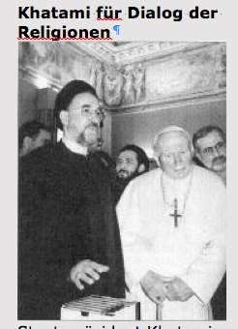
Khatami für Dialog der Religionen'.
'Dialog der Götter. Universal Declaration of the Sacred and Violence_ 'Prinzip 'des Glaubens… Greuel von Feuer und Schwert'… Gott gegen Mensch. 'Staat gegen Volk'…, Todestrieb gegen Lebenstrieb. 'History of anlaity… Identity of the Devil as death instinct and the Devil as anality… The identity of God and the Devil' (MV-Sarafi-Shiraz)]_ ‘Schnüffelgott… Schnüffelstaat' (File 1980-2004)_ hinter dem Rücken des Volkes zum kräftigen Zuschlgen]].
by Akbari and Ramezani as torturers (hours and hours I want to do something simple and it doesn't work…), the webhosts of 'mihanwebhost.com' in the city of Rasht
[affiliated, among others, with German Linux (cf. file 'See fist'. This 'mihan [homeland]… 'is set up to provide websites and damage and disable websites [cf. 'It is incumbent on this office to set up Internet' (file 'Austrian-Iranian Citizen'): 'Khadamat-e Doulat'],
under the leadership of the Lahijanian architect Amin Shafaati: I can't refrain from the thrill being a disgusting villain.

Parallel with westernization and jewification of 'the Islamic republic's clerical establichment' (President Rouhani), we have also its corresponding social cleansing practice with its political adversary Saudi Arabia: 'The New York Times says MBS authorised a clandestine campaign against Saudi dissenters before Jamal Khashoggi's murder (Yahoo March 18 2019). And 'the Revolutionary Court conducts closed-door hearings over alleged threats to Iran’s government' (Yahoo March 7 201). Cf. 'MV-Sarafi-Shiraz'.

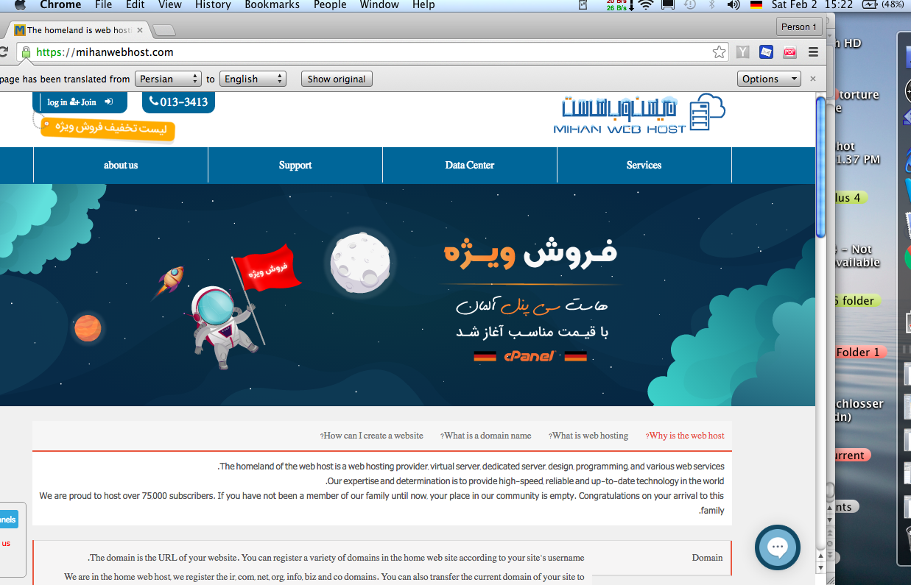
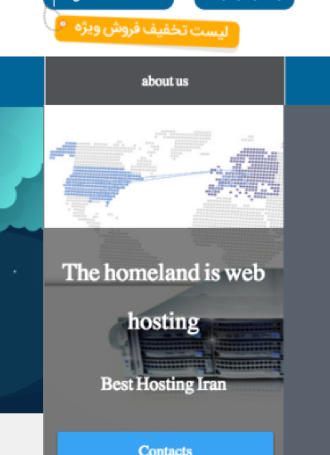
There are all kinds of enjoyments: e.g. sadism and destruction
[Gott_ 'Ausgeburt des herrschsüchtig-ausbeuterisch-sadistischen Geists' (File Strong Republic)_
'Der Sadismus des Herrn' und der Gottesstaat als der sadistische Staat' (ÖKS)_,
'als Gegensein': 'Save alive nothing that breatheth…, destroy them, and put their property under ban. Spare no one; put them all to death, men and women, children and babes in arms' (ÖKS). 'Universal declaration of the sacred and violence' (MV-Sarafi-Shiraz)],
appearing in the gestalt of God as the ideological wrapped-up of the death instinct [cf.: 'Menschliche Wurzeln der Gottheit' (Ö Zusatz 2)].
Der Todestrieb wurde als Anbetungsphantom in den Himmel geschoben, um, mit den Worten von Arno Gruen, 'im Mantel eine[r] autoritäre[n] Ideologie [in letzter instanz der Gott-Ideologie], die Mordlust vor sich selbst zu verbergen'.
The destructive encroachment on my computer is the act of God through its mercenaries in the 'mihanwebhost.com'_
God says: 'Devil, you are indeed a murderer and a wicked spirit ['disgusting villain'], but I will use you for my purposes' (1980-2004). 'CIA clandestine operations could require work with people with 'unsavory reputations' including criminals' (Martin Schulz): '… fun, fun, fun… lie, kill, cheat, rape, and pillage with the sanction and blessing of the All-Highest' (1980-2004).

'… die 'feindseligen, destruktiven und negativen Züge' des Christentums ['universal declaration of the sacred and violence' ('Khatami für Dialog der Religionen')]…, 'an die destruktivsten Züge des menschlischen Seins appelliert, sie heraufbeschwört ['instigated by the ruling power'] und ideologisch sanktioniert': 'lofty ethic' ['in the service of truth and justice']'.

'Menschenverbrennung' als 'Seelenrettung'/'Rassenrettung'.

"Theology [did not] create cruel impulses, but [gave] them the sanction of… a lofty ethic… Theology has encouraged man's natural savagery ['extremes of savagery… in the Bible']

"The Lord ['Gegensein', 'death instinct'] commands the Israelites to seize the lands occupied by other peoples, promising he will aid them in their battles ['with the sanction and blessing of the All-Highest']''…, the Israelites completely destroyed them ['all kinds of enjoyments: e.g. sadism and destruction'] and their cities, and named the place Hormah… 'Hormah' means in Hebrew 'destruction' [cf. 'jewification'] … 'All the people will see what great things [e.g. My scores were submerged in water 'because his storage room was flooded' (Nikos Grivas)] I, the Lord ['death instinct': 'menschliche Wurzeln der Gottheit'], can do' (Ö Zusatz 2) through his mercenaries: 'damage, disable' website_,
giving them a euphoric drainage (ejaculation) of the death-instinct (catharsis)_
Vgl. 'Dem staatlich kriminellen 'We-the-Team' gewährt die katholische Heiligkeit, mit lebendigem Geist der Inquisition ('Seelenrettung' als 'lofty ethic'), kräftige Ejakulationen des Todestriebs, der Mordlust, des Sadismus, des Verbrechens ('genuin vergöttlichte Verbrecher' und euer 'Verbrechen ist aus Pietätsgründen'): 'institutionalized acts of sadism…, prescribed by the society as normal, pleasurable acts' (Ö Zusatz 2)_,

um sie durch diese Abfuhr libidinös fester an den Staat zu binden.

The man Mohammad Ramezani enjoyed each time he punctured with his USB disk 'secrets' out my brain

[My website_ clearly debates/elborates my 'secrets'_ is not enough. My 'secrets' must be stolen [stolen fruit the sweetest. 'The sweet taste of betrayal' (Shafaati)]: Sanctification of voyeurism by the 'clerical establishment'],

imagining to catch a 'big fish'

as evidence for my plans to destroy Islamic Republic and the horrific punishment for me as a result of his loyalty to God by fighting its enemy, fulfilling the hidden political function of 'mihanwebhost.com' he, Shafaati and Akbari serve,

get applause and benefits, economic or else…

Happy, Happy Gang. Halleluja.

in web: WordPress eliminated…

You, the Team, Amin Shafaati, Reza Akbari, Mohammad Ramezani ['We… copying files'; 'copied as much as possible files']_

as in the case of the Christian Arab, Dimitris Tzafaras, who stole my scores_,

'sit on the material ['my secrets'] you have stolen and masturbate to death' (2004-2009+).

'The raiders went out… and brought back the heads, hands, and feet of their victims. A great feast and dance followed' (Ö Zusatz 2).
Großmasturbationsveranstaltung bei 'mihanwebhost.com'].

And, as in the case of the Christian Arab_

'Schwein…', fügte ich hinzu, und versetzte ihm einen rechten Haken. Er fiel zu Boden‘ (2004-2009+). 'I landed a blow on his jaw' (MV-Sarafi-Shiraz)_,

feel a heavy blow on your jaw and feel it time and again.


Wahn und Verbrechen, Jonoon va Jenayat (Farsi), 'Sacred and violence', go hand in hand. Heiligkeit als 'Extroversion' des Todestriebs, die Ideologie von Mordlust.

This website is written for German-speaking reader. English is international language.

